**Project Design Phase-II**

**Data Flow Diagram & User Stories**

|  |  |
| --- | --- |
| Date | 22 October 2022 |
| Team ID | PNT2022TMID06107 |
| Project Name | Project – Personal Assistance for Seniors Who Are Self-Reliant |
| Maximum Marks | 4 Marks |

**Data Flow Diagrams:**

A Data Flow Diagram (DFD) is a traditional visual representation of the information flows within a system. A neat and clear DFD can depict the right amount of the system requirement graphically. It shows how data enters and leaves the system, what changes the information, and where data is stored.

**Flow diagram for** Personal Assistance for Seniors Who Are Self-Reliant :

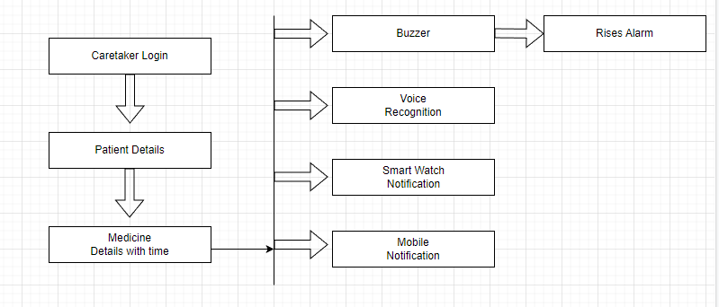

**User Stories**

Use the below template to list all the user stories for the product.

| **User Type** | **Functional Requirement (Epic)** | **User Story Number** | **User Story / Task** | **Acceptance criteria** | **Priority** | **Release** |
| --- | --- | --- | --- | --- | --- | --- |
| Customer (Mobile user) | Registration | USN-1 | As a user, I can register for the application by entering my email, password, and confirming my password. | I can access my account / dashboard | High | Sprint-1 |
|  |  | USN-2 | As a user, I will receive confirmation email once I have registered for the application. | I can receive confirmation email & click confirm | High | Sprint-1 |
|  |  | USN-3 | As a user, I can enter patient details. | I can register & access the patient details. | High | Sprint-1 |
|  |  | USN-4 | As a user, I can give the medicine details with correct dosage and time. | I can ensure the medicine details are stored in cloud. | High | Sprint-1 |
|  |  | USN-5 | As a user, I will be notified by alarm and medicine name. | I can receive the alarm. | High | Sprint-1 |
|  |  |  |  |  |  |  |
|  |  |  |  |  |  |  |
| Customer Care Executive | Creating awareness |  | As a customer care executive, I can advertise the product to people. | I can ensure the benefit of caretakers. | High | Sprint-1 |
| Administrator |  |  | As a administrator I will create a cloud storage to store the medicine details | I can remind the medicine name at the correct time | High | Sprint-1 |
|  |  |  |  |  |  |  |
|  |  |  |  |  |  |  |
|  |  |  |  |  |  |  |